1.1.3. Calculate Area of the Square
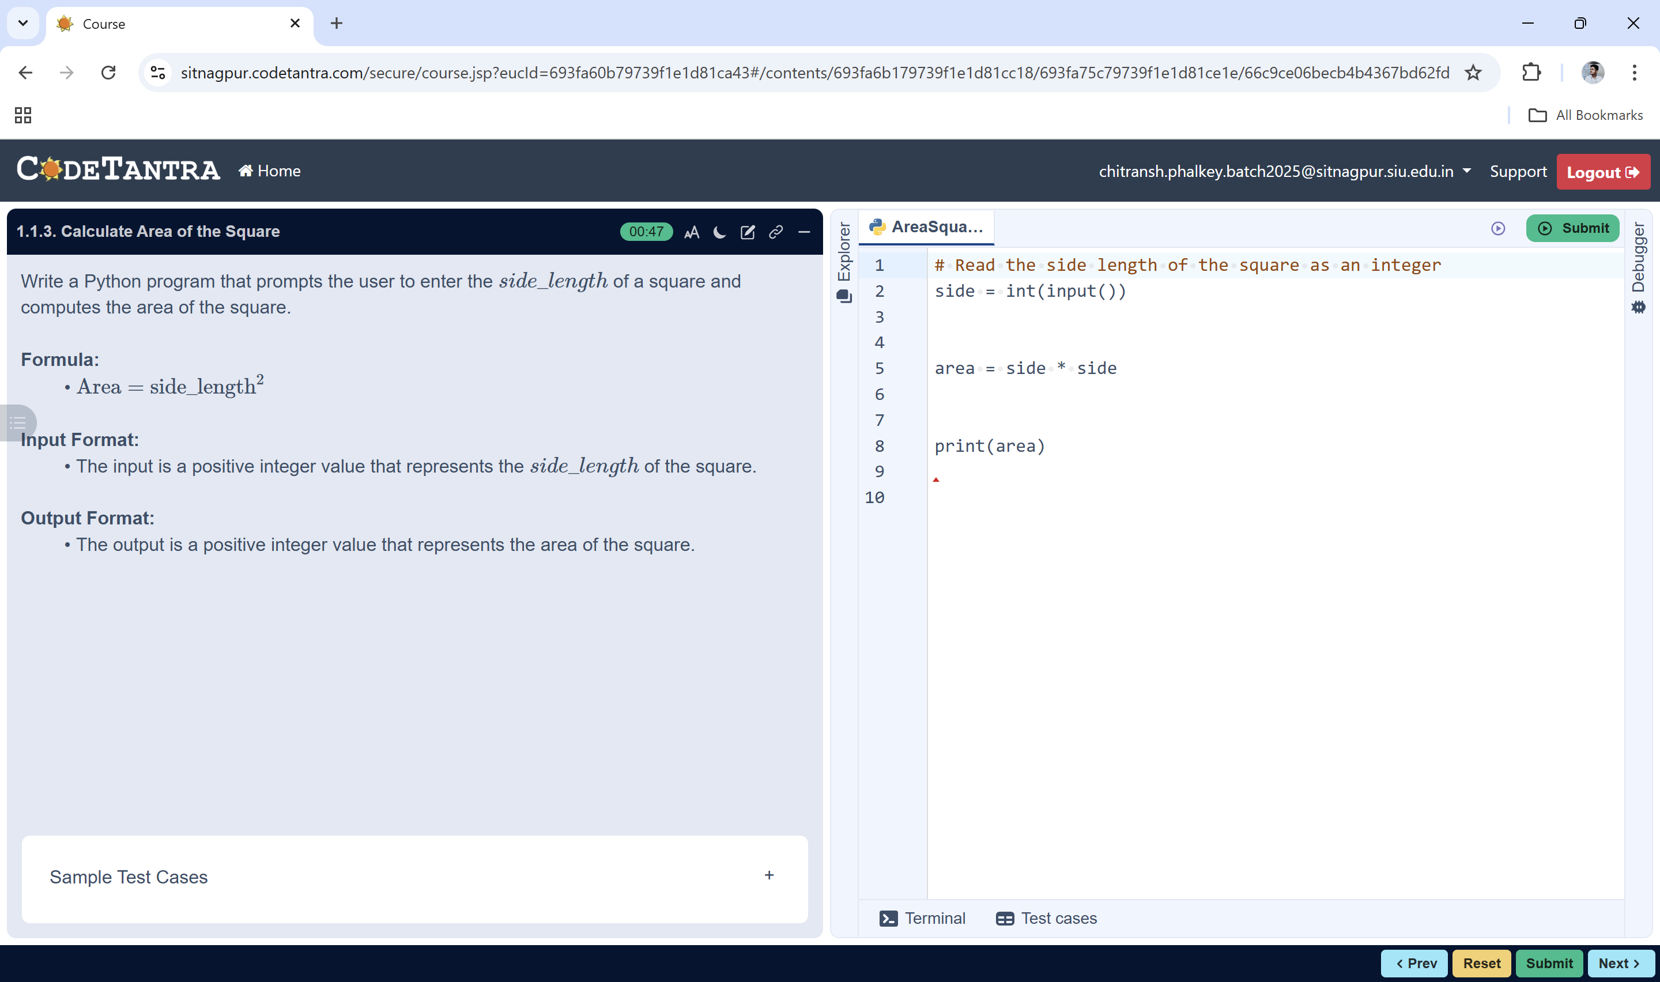
Input side
START

Algorithm: Area of a Square
area = side × side
- Start
- Read the value of side from the user
- Calculate the area using the formula:
area = side × side
Print area
- Display the value of area
- Stop
STOP

